Exchequer Lite

“Dashboard.exe units and objects”

Beta Release Notes

This document provides information about the Dashboard.exe and the units included into the project. This document assumes that the readership is familiar with Delphi 6.0 development environment, XML, COM objects and Exchequer structure/functionalities.

The main Dashboard.exe units (and .dfm) can be found under “X:\EXCHLITE\ICE\Source\Dashboard” and “X:\EXCHLITE\ICE\Source\Dashboard\BaseFrames”.

These directories contain the following units:

uLogin.pas
uDashBoard.pas
uMailBoxBaseFrame.pas
uInboxFrame.pas
uOutboxFrame.pas
uRecycleFrame.pas
uDailyFrame.pas
uDailyScheduleTask.pas
uExportFrame.pas
uRequestSync.pas
uBulkExport.pas
uSync.pas
uEndofSyncRequest.pas
uDashSettings.pas
uCompany.pas
uUsers.pas
uDashConfig.pas
uAddressBook.pas
uCompImport.pas
uAddNewContact.pas
uDashGlobal.pas
uAddUserLogin.pas
uAddPop3Account.pas
uAbout.pas
uUpdateManagerPwd.pas
uDSRConfigFrame.pas

There are some helping files that can be found under “X:\EXCHLITE\ICE\Source\Common”.

uSystemConfig.pas
uADODSR.pas
uConsts.pas
uCommon.pas
uInterfaces.pas

This files and theirs definition are explained at the document ICE - DSR.DLL units and objects.doc;

uLogin.pas

This is the first form to appear when Dashboard is loaded. It is a basic user login/password control. The access can be done by the manager user or a stored user/password. Both user and manager are validated against the database. The manager password is stored into ICE system table while the user login and password are store into the user table. No major functionalities are exposed here because the control is done via a database object/function. The image below shows the Dashboard login.

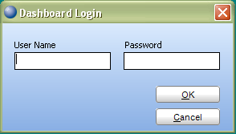
Image of Dashboard login

uDashBoard.pas

Main form where companies in Sync, Archived or deactivated can be shown. From this form, the user can start Sync Request, Bulk Export or just Sync. In addition to it, there is a possibility to add new users, new contacts change the Dashboard and DSR configuration settings or just create a new company. It is also possible to check the DSR status, start or stop the DSR service and change the manager password. All this operations can be done through a sequence key or just using the mouse. If in an event of DSR is offline, only the Dashboard settings can be changed. The Dashboard interface follows windows vista style and currently we are using TMS components to do it (http://www.tmssoftware.com) and the components can be found under “X:\COMPON\TMS”.
The Dashboard connects to the DSR service through a COM assembly called RemotingClientLib.dll. Basically, it needs a server and port to connect. Every operation, the Dashboard read a configuration file getting the server and port and doing the necessary call to it. The Dashboard only needs this DLL installed (to install this DLL Microsoft.Net MUST be installed in the machine) and the database server address for reading data. All updates are made by the DSR. Dashboard only gets data, never updates.
Callings are made by a unit called uDSR.pas that roughly imitates call functions of the DSR but with a machine and port as parameters. These two parameters enable the RemotingClientLib.dll call the WrapperDSRService.exe and then the DSR.DLL for exports, imports, etc.

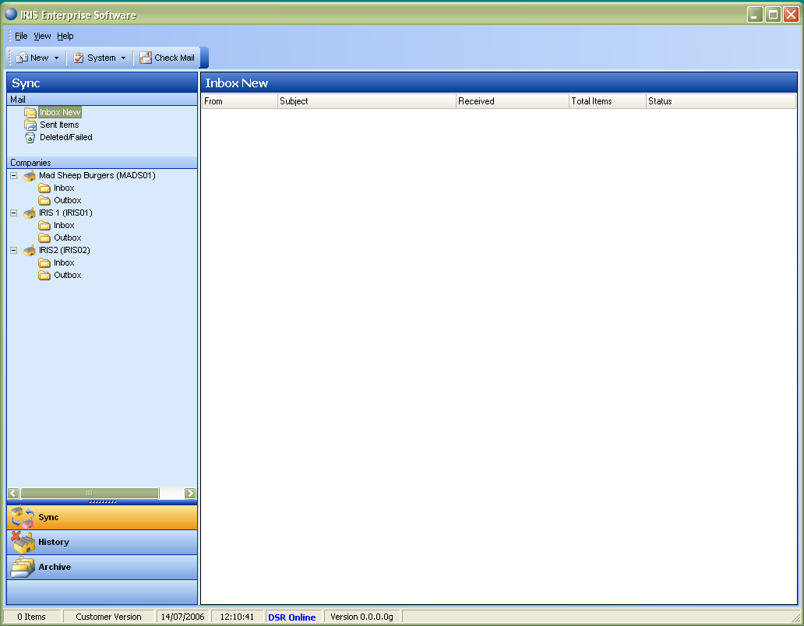
Image of the Dashboard main interface
The Dashboard exposes the following classes:

TMailBoxCompany: Every Inbox/Outbox that belongs to a company is an inherited TCompany object that exposes an Inbox or Outbox frame. This frame is loaded in the right side of the main window and can be easily noted because it holds the company name and what kind of “box” it is.

TDASHCheckComp: Thread inherited class that keeps updating the sync navigation bar when a user requests for creating a new company via Dashboard menu (File->System->Create Company or ALT-M).

TfrmDashboard: Main Dashboard class. From this class, the user can make requests; check the DSR status and so on. Many of the functions are component related and do simple things. The described methods below are the useful functions that help the Dashboard doing its tasks.

Methods:

Procedure Init;
Procedure LoadExchequerVersion;
Procedure SetTreviewSize;
Procedure LoadInboxNew(Const pShowForm: Boolean = True; Const pShowAlert: Boolean = True);
Function GetInboxNode: TTreeNode;
Function GetOutboxNode: TTreeNode;
Function GetRecycleNode: TTreeNode;
Procedure LoadSentItems(Const pShowForm: Boolean = True);
Procedure LoadRecycle(Const pShowForm: Boolean = True);
Procedure LoadCompanies;
Function CreateCompanyMailBox({pComp: OleVariant;}pComp: TCompany; pMailBox: TBoxType; Const pMenuActive: Boolean = True): TMailBoxCompany;
Procedure GetDripFeedParams(pCompany: Longword; Var pParam1, pParam2: WideString);
Procedure DeleteNode(pNode: TTreeNode);
Procedure RemoveChild(pNode: TTreeNode);
Function FindBoxNode(Const pName: String): TTreeNode;
Function FindNode(Sender: THTMLTreeview; Const pExCode: String): TTreeNode;
Procedure SetStatusBarItemCount(pTotal: Integer);
Procedure BringFrametoFront(pFrame: TfrmMailBoxBaseFrame; Const pCaption: String);
Procedure OpenEventLog;
Procedure CloseLog;
Procedure CheckDSRStatus;
Procedure HideMenus;
Procedure HideFrames;
Function GetSelectedFrame: TfrmMailBoxBaseFrame;
Procedure ChangeActionStatus(Const pCategory: String; Const pValue: Boolean);
Function CompanyHasReqBulk(Const pGuid: String): Boolean;
Procedure CompanyCreateBulk(Const pGuid: String);
Procedure CompanyDeleteBulk(Const pGuid: String);
Procedure UpdateCompanyInboxNode(pCompany: Integer; Const pText: String);
Procedure UpdateInboxNode(pCompany: Integer; Const pText: String);
Procedure UpdateInboxAfterLoad(pResult: Longword);
Procedure UpdateOutboxAfterLoad(pResult: Longword);
Procedure UpdateCompany;
Procedure UpdateAfterCallDSR(pResult: Longword);
Procedure AfterUpdateMessage(Sender: Tobject; pMsg: TMessageInfo);
Procedure CheckCompanies(pFromMenu: Boolean);

Note: Loading the Dashboard as a standalone application with the DSR service running in another machine, it might take a little bit longer to load because the Dashboard tries to check and verify the service where the service is installed. It gives to the user full control to start and stop the service whenever the user wants.

uMailBoxBaseFrame.pas

Base frame for manipulate the incoming and outgoing messages. It basically manipulates the messages according to their status. The main component is a TMS ADVOutlookList. Inbox, Outbox, Recycle and Company Inbox/Outbox inherit their frames from this base frame doing the necessary changes to manipulate/control data according.

TfrmMailBoxBaseFrame: Set of functions and properties to manipulate TMS ADVOutlookList.

Methods:

Procedure SetBoxType(Const Value: TBoxType);
Function GetItemsCount: Longword;
Function GetPanelCaption: String;
Procedure SetPanelCaption(Const Value: String);
Function GetBold(pCond: Boolean): String;
Function GetSelectedMsgInfo: TMessageInfo;
Function GetTimerActive: Boolean;
Procedure SetTimerActive(Const Value: Boolean);
Procedure ResizeHeaders;
Function GetFocused: TStrings; Virtual;
Function GetMailInfo: TMessageInfo; Virtual;
Function MailExists(Const pGuid: String): TStrings;
Procedure DeleteItem(pInfo: TMessageInfo);
Procedure LoadMessages(pMsgs: Olevariant; Const pShowAlert: Boolean = False; Const pForceUpdate: Boolean = False); Virtual;
Function GetGroup(pDate: TDate): TOutlookGroup;
Function GroupExists(Const pName: String): TOutlookGroup;
Procedure ClearItems;
Procedure AddMessageDetail(Var pMail: TStrings; Var pInfo: TMessageInfo; Const pCaption: String; Const pUseBold: Boolean = False); Virtual;
Procedure DeleteSelectedMessages; Virtual;

Properties:
Property OnUpdateInboxNode: TOnUpdateInboxNode;
Property OnAfterLoadMessages: TOnAfterLoadMessages;
Property OnCreateCompany: TOnCreateCompany;
Property OnAfterCallDSR: TOnAfterCallDSR;
Property OnDeleteMessage: TOnDeleteMessage;
Property OnBeforeDelete: TOnBeforeDelete;
Property OnCanDelete: TOnCanDelete;
Property OnAfterUpdateMessage: TOnAfterUpdateMessage;
Property BoxType: TBoxType Read fBoxType;
Property Count: Longword;
Property PanelCaption: String;
Property HasFocus: Boolean;
Property SelectedMsgInfo: TMessageInfo;
Property LastUpdate: TDatetime;
Property MenuActive: Boolean;
Property Company: Integer;
Property Archive: Boolean;
Property TimerActive: Boolean;
Property MailBoxName: String;

uInboxFrame.pas

Inherited frame of TfrmMailBoxBaseFrame, this class basically encapsulate functionalities of the Inbox table. The main task here is let the user Import a batch of files by just clicking the mouse over one of the items no the screen. This form also shows the result of events from the sender/receiver. An example of this is an End of Sync request. The user will not be able to do any others Sync while the user do not apply the End of Sync as well.

TfrmInboxFrame:

Methods:
Procedure LoadMessages(pMsgs: Olevariant; Const pShowAlert: Boolean = False; Const pForceUpdate: Boolean = False); Override;
Function DeleteMessage(pGuid: TGuid): Longword;
Procedure CanDelete(pGuid: TGuid; pStatus: Longword; pMode: Smallint; Var pCanDelete: Boolean);

Properties:
property CompanyActive: Boolean;

uOutboxFrame.pas

Inherited frame of TfrmMailBoxBaseFrame, this class basically encapsulate the functionalities of the outbox table. As the tasks are made by the Dashboard main screen, this form shows the result of the requests (Sync Request, Bulk Export and Sync). The user can also add a scheduled message and delete data when necessary.

TfrmOutboxFrame:

Methods:
Procedure LoadMessages(pMsgs: Olevariant; Const pShowAlert: Boolean = False; Const pForceUpdate: Boolean = False); Override;
Function DeleteMessage(pGuid: TGuid): Longword;
Procedure CanDelete(pGuid: TGuid; pStatus: Longword; pMode: Smallint; Var pCanDelete: Boolean);

uRecycleFrame.pas

Inherited frame of TfrmMailBoxBaseFrame, this class basically loads messages that has been deleted or failed from outbox and inbox tables. One important item here is that whatever message that a user deletes, it comes straight to this frame. Only from this frame it is possible to delete a message from Ice database and File system. Otherwise, all messages have just their status changed.

TfrmRecycleFrame:

Methods:
Procedure LoadRecycleMessages(pMsgs: Olevariant; pBox: TBoxType);
Procedure AddMessageDetail(Var pMail: TStrings; Var pInfo: TMessageInfo; Const pCaption: String; Const pUseBold: Boolean); Override;
Function DeleteMessage(pGuid: TGuid): Longword;

uDailyFrame.pas

This is a base frame that encapsulates Daily Schedule options. Basically, a user can chose date to start/finish the scheduling, time to export (it works when the company is in Drip Feed mode) and the frequency of the schedule (daily, week days or every “x” day).

TfrmDailyFrame:

Method:
Procedure DisableAll;

uDailyScheduleTask.pas

This form contains the TFrmDailyFrame and writes a database entry when a user requests a scheduled option.

TfrmDailyScheduleTask:

Properties:
Property MailInfo: TMessageInfo;
Property AddNew: Boolean;

uExportFrame.pas

This frame contains most of the functionalities for an export operation. It does not write any entry to the database, but this frame treats/manipulates the user entry data and ensures the values are correct and a message can be sent to a target user. This form also contains the Address Book functionalities allowing a user to call the form and select a target e-mail.

TfrmExportFrame:

Methods:

Procedure LoadAddressBook;
Procedure LoadExportPackages(Const pCompany: Longword = 0);
Procedure LoadCompanies;
Procedure SetRequestSync(Const Value: Boolean);
Procedure SetBulkExport(Const Value: Boolean);
Procedure ClearComboBoxes;
Procedure ClearCompanies;
Procedure ClearJobs;
Function SelectCompany(Const pExCode: String): Boolean; Overload;
Function SelectCompany(pId: Integer): Boolean; Overload;
Procedure SetExportDetails(pMsg: TMessageInfo; Const pSubj: String = ''; Const pParamYear1: String = ''; Const pParamYear2: String = '');
Function ValidatePeriod(pCompany: Integer): Boolean;
Function SelectDripFeed: Boolean;
Procedure HidePeriods;

Properties:

Property RequestSync: Boolean;
Property BulkExport: Boolean;

uRequestSync.pas

With mainly performing functionalities of TfrmExportFrame, this form performs Sync Requests to a target user. This form is the beginning of the Synchronization and can only be called when the Company in questions is not in Drip Feed mode.

TfrmRequestSync

uBulkExport.pas

With mainly performing functionalities of TfrmExportFrame, this form performs Bulk Exports to a target user. This form is the second step of the Synchronization and can only be called after the acceptance of the Sync from a target system.

TfrmBulkExport:

Property:
Property MailInfo: TMessageInfo

uSync.pas

With mainly performing functionalities of TfrmExportFrame, this form performs a proper Sync to a target system. This form is the third step of the synchronization and can only be called after a Bulk Export.

TfrmSync:

Property:
Property MailInfo: TMessageInfo

uEndofSyncRequest.pas

With mainly performing functionalities of TfrmExportFrame, this form performs and End of Sync Request to a target user. This form is the last step of a Sync operation and can only be called when Exchequer is in Drip Feed Mode.

TfrmEndofSyncRequest

uDashSettings.pas

This is a unit for quick loading/setting the Dashboard configuration.

Methods:

Function _DashboardGetDBServer: String;
Procedure _DashboardSetDBServer(Const pServer: String);
Function _DashboardGetDSRServer: String;
Function _DashboardGetDSRPort: Integer;
Function _DashboardGetCompanyMail: String;
Function _DashboardGetCompanyName: String;
Function _DashboardGetShowAlert: Boolean;

Procedure _DashboardSetDSRServer(Const pServer: String);
Procedure _DashboardSetDSRPort(pPort: Longword);
Procedure _DashboardSetCompanyMail(Const pCompanyMail: String);
Procedure _DashboardSetCompanyName(Const pCompanyName: String);
Procedure _DashboardSetShowAlert(Const pShowAlert: Boolean);

uCompany.pas

This form allows a user to create/verify companies into the system. The ICE database holds information about the Exchequer companies and this form provides a way for the user to see this data and also create a new company when necessary or if there are company licenses available to do it.

TfrmCompanyManager:

Method:
Procedure LoadCompanies;

uUsers.pas

This form allows a user to manipulate user login data. The Dashboard requires a user login/password to be able to do the tasks on the main screen. If no user logins are registered, Dashboard can only be manipulated by the “Manager” user and this user can never be deleted, but can change its password time to time. After entering on the main Dashboard screen, a manager can add/update users/logins for operational use. There is no restriction in terms of what a user can do. Once in the database, the user can do all types of requests on Dashboard.

TfrmUser:

Method:
Procedure LoadUsers;

uDashConfig.pas

This form allows a user to change the Dashboard settings. It also loads the DSR settings and a user can make any changes from this form. The Dashboard settings are read and written via DashSettings.pas and the DSR settings are read and written via RemotingClientLib.

TfrmConfiguration:

Methods:
Procedure LoadDashSettings;
Procedure LoadDSRSettings;
Procedure SaveDashSettings;
Procedure SaveDSRSettings;

uAddressBook.pas

Address Book format form that allows a user to manipulate contacts (company and e-mail). Filling this data, a user can call this form and add a contact e-mail when sending data to a target system. Also, it is possible to define a default company. Every time a request is made, the “to” field will be filled with the contact e-mail chosen. Another functionality used by the default company is Drip Feed mode. If automatic Drip Feed mode is set, the user must define a default company, otherwise the DSR can not detect what company to send data.

TfrmAddressBook:

Methods:
Procedure LoadAddressBook;
Procedure LoadCompanies(Var pCombo: TComboBox);
function GetCompanyDesc(pCompany: Longword): String;
Function CheckCompany(pCompany: Longword): Boolean;

Property:
Property SelectionMade: Boolean;

uCompImport.pas

This is an optional form for choosing a company to import data. If for some reason the DSR could not get the correct company for a batch, the message appears in the “Inbox New” and the user can select “Import To” and select the correct company to import the e-mail.

TfrmCompImport:

Method:
Procedure LoadCompanies;

Property:
Property MailInfo: TMessageInfo;

uAddContact.pas

This is a form for adding/updating dashboard user contacts.

TfrmAddNewContact:

Method:
Procedure SetEditContact(Const Value: Boolean);

Property:
Property EditContact: Boolean;
Property OldContactMail: String;
Property OnCheckDefault: TOnCheckDefault;

uDashGlobal.pas

This is a unit that holds global variables for the Dashboard.

uAddUserLogin.pas

This is a form for adding/updating a user login/password.

TfrmAddUserLogin:

Methods:
Procedure SetEditUser(Const Value: Boolean);

Properties:
Property EditUser: Boolean;
Property OldUser: String;
Property OldPass: String;
Property OldLogin: String;

uAddPop3Account.pas

Unit responsible for adding/updating POP3 accounts. This unit is called through Configuration and it is part of the DSR e-mail monitoring.

TfrmAddPop3Account:

Method:
Procedure SetEditPop3(Const Value: Boolean);

Property:
Property EditPop3: Boolean

uAbout.pas

This form shows information about the system. Also, it is possible to see information about the versions in use.

TfrmAbout

uUpdateManagerPwd.pas

Form for updating the Manager password.

TfrmUpdateManagerPwd

uDSRConfigFrame.pas

Shared with Config.exe application, this frame load and edit the DSR configuration settings. It allows a system to change DSR settings on the fly without any impact in terms of functionalities.

TfrmConfiguration:

Methods:

Procedure LoadDashSettings;
Procedure LoadDSRSettings;
Procedure SaveDashSettings;
Procedure SaveDSRSettings;

